Exception
In Java, an exception is an event that disrupts the normal flow of the program. It is an object which is thrown at runtime.
Exception Handling
The Exception Handling in Java is one of the powerful mechanism to handle the runtime errors such as ClassNotFoundException, IOException, SQLException, RemoteException etc. We need to handle such exceptions to prevent abrupt termination of program.

Hierarchy of Java Exception classes
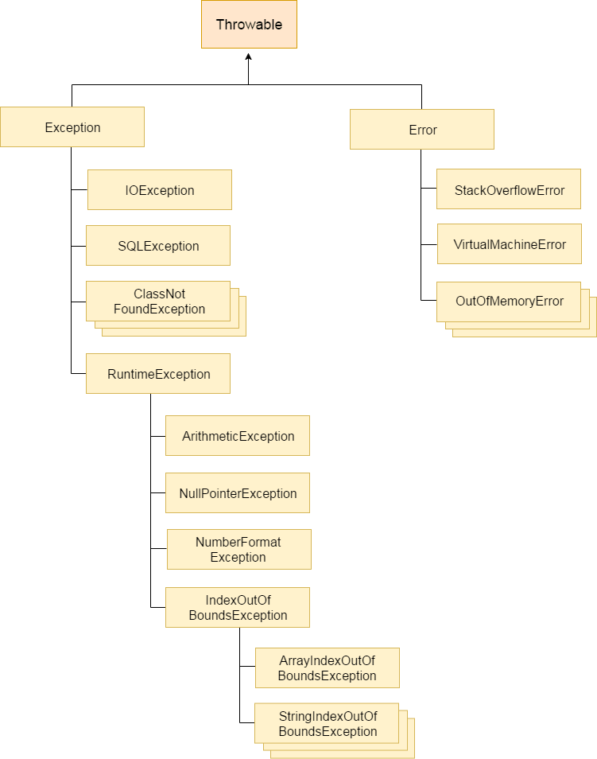

Types of Exceptions
Checked Exception: A checked exception is an exception that occurs at the compile time. the exceptions which directly inherits throwable class except runtimeException and error are checked exception. e.g IoException, SQLException, classNoitFoundException
Unchecked exceptions: An unchecked exception is an exception that occurs at the time of execution. These are also called as Runtime Exceptions. The classes which inherit RuntimeException are unchecked exceptions e.g. ArithmeticException, NullPointerException, ArrayIndexOutOfBoundsException etc.
3) Error: Error is irrecoverable e.g. OutOfMemoryError, VirtualMachineError, AssertionError etc.

Java Exception Keywords
- try: The "try" keyword is used to specify a block where we should place exception code. The try block must be followed by either catch or finally. It means, we can't use try block alone. Java try block is used to enclose the code that might throw an exception
- catch: Java catch block is used to handle the Exception by declaring the type of exception within the parameter. The declared exception must be the parent class exception ( i.e., Exception) or the generated exception type. However, the good approach is to declare the generated type of exception. It must be preceded by try block which means we can't use catch block alone. It can be followed by finally block later.
- finally: The "finally" block is used to execute the important code of the program. It is executed whether an exception is handled or not.
- throw:The "throw" keyword is used to throw an exception.
- throws: The "throws" keyword is used to declare exceptions. It doesn't throw an exception. It specifies that there may occur an exception in the method. It is always used with method signature.

Java Nested try block
The try block within a try block is known as nested try block in java.

Sometimes a situation may arise where a part of a block may cause one error and the entire block itself may cause another error. In such cases, exception handlers have to be nested

Java finally block
Java finally block is a block that is used to execute important code such as closing connection, stream etc.
Java finally block is always executed whether exception is handled or not.
Java finally block follows try or catch block.
Finally block in java can be used to put "cleanup" code such as closing a file, closing connection etc.
Rule: For each try block there can be zero or more catch blocks, but only one finally block.

Java throw keyword
The Java throw keyword is used to explicitly throw an exception.
We can throw either checked or uncheked exception in java by throw keyword. The throw keyword is mainly used to throw custom exception.
Sysntax: throw new exception;

Java throws keyword

The Java throws keyword is used to declare an exception. It gives an information to the programmer that there may occur an exception so it is better for the programmer to provide the exception handling code so that normal flow can be maintained.
return_type method_name() throws exception_class_name{
//method code
}

Which exception should be declared
checked exception only, because:
- unchecked Exception: under your control so correct your code.
- error: beyond your control e.g. you are unable to do anything if there occurs VirtualMachineError or StackOverflowError.
Rule: If you are calling a method that declares an exception, you must either caught or declare the exception.
There are two cases:
- Case1:You caught the exception i.e. handle the exception using try/catch.
- Case2:You declare the exception i.e. specifying throws with the method.

Java Custom Exception
If you are creating your own Exception that is known as custom exception or user-defined exception. Java custom exceptions are used to customize the exception according to user need. By the help of custom exception, you can have your own exception and message.

